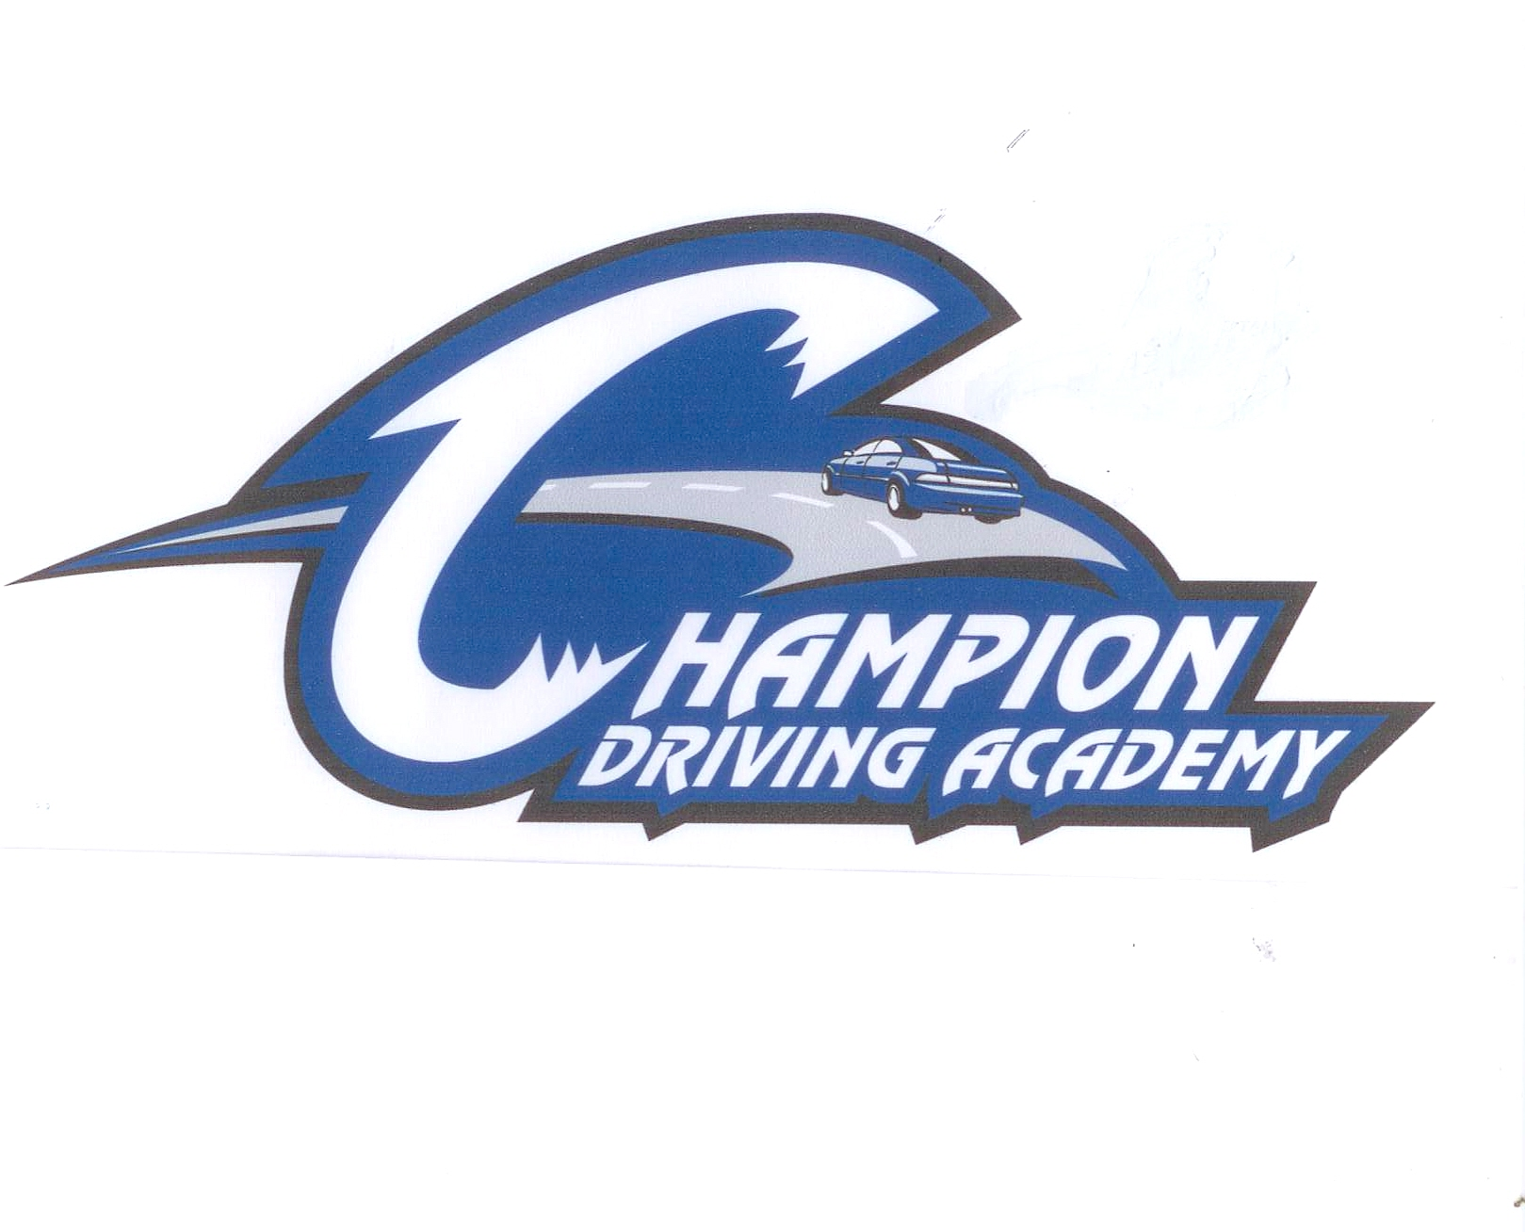
Champion Driving Academy #1117

CONFIRMATION

Student Name:
Legal Guardian/Parent Name:

Classroom Session:

Edmond Office: 2329 West 15th Suite D-NW corner of 15th & Santa Fe

First day of class-Please bring: Balance
Signed Contract
Money for Lunch (area restaurants)
Second day of class-We will schedule the 3 two-hour driving sessions.

RECEIPT
DEPOSIT: DATE:
BALANCE DUE: :CHECK: DATE:

CONTRACT

I am aware that driving instruction is a hazardous activity, and I am voluntarily participating in this activity with knowledge of the danger involved and hereby agree to accept any and all risks of property damage, personal injury, or death.

In consideration of my participation, I hereby release Champion Driving Academy, LLC and any of its instructors or agents from any present and future claim, including negligence, for property damage, personal injury, or wrongful death, arising from any participation in driving instruction activities.

Furthermore, I hereby voluntarily waive any and all claims, both present and future, arising from my participation in driving instruction activities, including but not limited to negligence, property damage, personal injury, and wrongful death.

I hereby acknowledges to Champion Driving Academy, LLC that I am in good physical health and am physically able to undertake and complete the instruction contemplated and to be provided under this Agreement without any detriment either to myself, the Champion Driving Academy, LLC or others. I state that there are no health-related reasons or problems which preclude or restrict my participation in the subject of this Agreement

I understand that to complete the driver education course, the student must finish 10 hours of classroom instruction and 6 hours of “behind the wheel” instruction with a certified instructor from Champion Driving Academy. The participant must fulfill the financial obligation of $360 in order to receive certification. After attendance of the first class, there is no refund. Failure to attend one of the driving sessions without prior notification 24 hours in advance to the instructor may result in a $30 penalty per hour. In addition, the participant has 12 month to finish the course after the first day of class.

Please read and sign the following:

I absolve the Champion Driving Academy, LLC and anyone else involved directly or indirectly with the driving instruction from any liability for injury or illness suffered by me or my dependent(s) in connection with driving instruction activities. If my dependent or I should suffer an injury or illness as result of driving instruction activities, I authorize the instructors to use their discretion to have me or my dependent transported to a medical facility and I take full responsibility for their action.

Student’s Signature _______________________________________Date_________

Legal Guardian/Parent Signature _____________________________Date________

Make check out to: Champion Driving Academy ____________________________ Michael Tucker #7140

**If you are taking the written test at the Department of Public Safety, this form must be signed and stamped to obtain your learner’s permit. You must have the CHAMPION DRIVING ACADEMY CERTIFICATE for the driving test. You must also have the certificate to obtain your learner’s permit if you are exempt from the written test (you are exempt if you have finish our driver education course and are15½).

